Keszler, 03.05.2024
Bram, 23.05.2024

Revision of manuscript PMG-24-0005
Field assisted sintering and spark plasma texturing of Nd-Fe-B magnets with tailored anisotropic magnetic properties

M. Keszler¹, I. Radulov², F. Maccari³, T. Mutuk^{1,4}, M. Krengel⁵, O. Guillon^{1,6}, O. Gutfleisch³, M. Bram^{1,7}

1) Forschungszentrum Jülich, Institute of Energy and Climate Research, IEK-1: Materials Synthesis and Processing, 52425 Jülich, Germany.
2) Fraunhofer Research Institution for Materials Recycling and Resource Strategies IWKS, 63457 Hanau, Germany.
3) Technical University of Darmstadt, Institute for Materials Science, Functional Materials, 64287 Darmstadt, Germany.
4) Ondokuz Mayis University, Department of Metallurgical and Material Engineering, 55139, Atakum, Samsun, Turkey.
5) M. Krengel, Wilo SE, Magnetprototyping & Development Magnetic Materials, 44263 Dortmund, Germany.
6) Jülich Aachen Research Alliance, JARA-FIT, 52425 Jülich, Germany.
7) Ruhr University Bochum, Institute for Materials, 44801 Bochum, Germany.

Abstract
Field assisted sintering technologies like spark plasma sintering (FAST/SPS) are attractive alternative methods for the processing of nanocrystalline Nd-Fe-B magnets with well-pronounced anisotropic magnetic properties. For conducting a respective FAST/SPS cycle, a moderate load is applied on a pre-compacted or pre-sintered sample, followed by pre-heating in a suitable designed tool up to the deformation temperature. Then, hot deformation is done by increase of the load at deformation temperature. This work aims to investigate the potential of hot deformation through FAST/SPS, a method commonly referred to as spark plasma texturing (SPT). As SPT can have its parameters, such as heating rate and applied uniaxial pressure, fine-tuned and closely monitored, optimization of SPT may lead to finer microstructure development control and reproducibility when compared to traditional hot deformation. This fine control has the potential to expand beyond the consolidation of nanocrystalline melt-spun starting powder and into other starting powders. This work focuses on two different routes of SPT both starting from the same commercial melt-spun Nd-Fe-B powder (Magnequench MQU-F). One deals with the SPT of semi-dense MQU-F compacts, while the other focuses on deformation of MQU-F dense compacts. Semi-dense compact SPT could lead to new routes for the consolidation of anisotropic Nd-Fe-B magnet scrap without inducing excessive grain growth, while dense compact SPT has the possibility of greater microstructural development control when compared to traditional hot deformation.

1. Introduction
Nd-Fe-B magnets play an important role in our daily life due to their widespread application in wind turbines, electric vehicles, hybrid electric vehicles, e-bikes, consumer goods, computers and green energy technologies [Sugimoto 2011, Gutfleisch 2011]. The weight of magnets in these applications varies from tons down to several grams [Yang 2017]. The preference for using Nd-Fe-B magnets is derived from these magnets having the highest energy-product, (BH)_{max}, at room temperature (theoretical 512 kJ⋅m⁻³) among all permanent magnet materials currently available on the market. Processing of Nd-Fe-B magnets is traditionally based on powder metallurgy. There are two main processing routes established, which differ in the kind of starting powder and either result in microcrystalline or nanocrystalline magnets.

For the manufacturing of microcrystalline Nd-Fe-B magnets, powder production starts from melting and strip casting of the alloy [Yang 2017, Gutfleisch 2000a]. The produced flakes are comminuted by hydrogen decrepitation and afterwards jet milled, resulting in a powder with a particle size in the range of 1 – 10 µm. The shaping of the powder is done by conventional powder metallurgical methods like uniaxial or cold isostatic pressing. A peculiarity of magnet production is the alignment of the powder particles before or during compaction by applying a magnetic field in the range of 10 – 20 kOe (1 – 2 T, 796 – 1592 kA⋅m⁻¹). Finally, the magnets are sintered with a transient liquid phase under protective atmosphere at temperatures in the range of 1000 – 1100°C.

For the manufacturing of nanocrystalline Nd-Fe-B magnets, different kinds of nanocrystalline starting powders can be applied, melt-spun powders [Croat 1984, Lee 1985], mechanically alloyed powders [Schultz 1987] and, hydrogenation-disproportionation-desorption-recombination (HDDR) powders [McGuiness 1992, Nakayama 1993]. In the case of melt-spinning, the Nd-Fe-B alloy melt containing all alloying elements is ejected on a rotating copper wheel resulting in quenched ribbons or flakes with a size in the range of several 100 µm. To ease the subsequent powder processing, the size of the flakes can be decreased by milling or crushing. Due to rapid solidification, the primary grains of the main Nd₂Fe₁₄B phase in the flakes remain nanocrystalline with a size in the range of 10 – 30 nm [Hioki 2021]. For mechanical alloying, the alloying elements are blended in the aspired composition and homogenized by high-energy ball milling in a planetary ball mill [Schultz 1987]. In the case of HDDR [McGuiness 1992], the alloy composition is first melted in a protective atmosphere (e.g., by plasma arc melting) and then heated in hydrogen. The Nd-Fe-B matrix phase becomes disproportionated to finely distributed iron, ferroboron and neodymium hydride phases. Afterwards, it is recombined under vacuum in the temperature range of 750 – 830°C. The reformation of the Nd-Fe-B phase is coupled with the formation of very fine grains down to the several 100 nm range. Usually, HDDR powders already exhibit anisotropic magnetic properties.

Nanocrystalline Nd-Fe-B powders can be directly used in polymer bonded magnets, resulting in a good compromise of isotropic magnetic properties and costs. As an alternative, nanocrystalline Nd-Fe-B powders can be used as starting material for the manufacturing of high-performing fully dense anisotropic magnets by applying a multiple-stage production process [Hioki 2021, Khlopkov 2007, Song 2013, Croat 2018, Gutfleisch 2000b]. In principle, all kinds of nanocrystalline powders can be used as starting material [Kirchner 1998], but melt-spun powders have the highest potential for studying the microstructure formation as function of processing parameters and to benchmark different processing technologies due to starting from ultrafine, uniform primary grains. Contrarily, HDDR powders have a coarser grain structure than melt-spun ribbons and hence show greater deformation resistance during the fabrication of a textured Nd–Fe–B magnets. This enhances the risk of cracking of the samples [Gopalan 2009] and usually leads to lower texturing after hot deformation [Kirchner 1998, Ikram 2019, Ikram 2020]. As a first step of the multi-stage production process, the powder is cold pressed into compacts. Then, the compacts are fully densified by hot pressing at temperatures in the range of 650°C – 900°C and a pressure of up to 300 MPa [Song 2013, Croat 2018]. During hot pressing, anisotropic grain growth along the a-axis of the Nd₂Fe₁₄B crystal already starts, which becomes more pronounced with increasing temperature [Hioki 2021] In the as-hot-pressed state, the microstructure contains randomly aligned grains with a size in the range of 20 – 50 nm. Due to the random orientation of the grains, isotropic magnetic properties are obtained at this stage. As a final step, anisotropic magnetic properties are achieved by hot deformation of the hot-pressed parts either by die-upsetting (plane magnets) or hot extrusion (ring magnets) [Grünberger 1997]. A deformation degree – defined by height reduction in relation to the initial height – of up to 75 % can be achieved by applying temperatures in the range of 650°C – 900°C and a pressure of up to 100 MPa [Hioki 2021, Song 2013, Croat 2018]. Deformation degree has a significant influence on magnetic behavior [Zhao 2021]. As the deformation degree increases, the fiber texture also increases, indicating a higher alignment of the “c” crystallographic/easy magnetization axis of the Nd-Fe-B grains along the pressure direction. This alignment leads to an increase in remanence and, consequently, energy-product [Khlopkov 2004]. On the nano-scale, anisotropic grain growth occurs resulting – in the ideal case – in plate-like grains with a width in the range of 200 – 500 nm and a height of 20 – 50 nm and fully aligned perpendicular to the deformation direction.

Different mechanisms have been proposed for the development of this texture, which are discussed in detail in the manuscript of Hioki [Hioki 2021]. It is stated that thermo-mechanical alignment of the crystal grains of Nd-Fe-B occurs at roughly 800 °C. Maintenance of temperatures above the melting point of the grain boundary phase is necessary for good formability due to enabling grain rotation and grain boundary sliding of the c-plane under the applied hot deformation stress. With further increase of temperature, this comes at the detriment of inducing abnormal grain growth [Mishra 1988, Mishra 1990, Hioki 2021]. In standard hot deformation, the grain alignment starts with the melting of the grain boundary phase coupled with anisotropic grain growth and grain boundary migration [Mishra 1990]. Then, under an applied stress, the platelet-shaped grains further develop anisotropy through atom transfer through the liquid grain boundary phase by a pressure assisted “solution-precipitation creep” mechanism [Grünberger 1997]. Partial solution of the bulk material changes the composition of the grain boundary phase during microstructure evolution. After hot deformation, the c-axis of the platelet-shaped grains align to be parallel to the pressing direction [Mishra 1990, Hioki 2021]. Another important influence factor – especially on the coercivity – is the thickness and composition of the temporarily molten grain boundary phase after its solidification. Liu et al. [Liu 2013] reports an increase of the coercivity with increasing thickness and Nd content of this grain boundary phase and explains this effect with an improved magnetic isolation of the grains.

Electric current assisted sintering (ECAS) technologies are an attractive alternative for hot deformation of nanocrystalline Nd-Fe-B magnets. It is expected that direct Joule heating of the compacts by current flow through the bulk in combination with the applied load further improves microstructure evolution. It has been demonstrated recently that there is a potential of ECAS technologies for the direct recycling of magnet scrap [Leich 2019, Mishra 2023, Keszler 2023], which is not accessible by the established technologies mentioned above. Several ECAS technologies have been investigated for the processing of Nd-Fe-B magnets so far. In all cases, melt-spun, nanocrystalline Nd-Fe-B powders or scrap from hot-deformed magnets has been used as starting materials.

1) Electro discharge sintering (EDS): Leich et al. reported the production of Nd-Fe-B Magnets with isotropic magnetic properties by EDS [Leich 2019, Leich 2018]. Due to densification in milliseconds by sudden release of energy stored in a capacitor, this method is the most economical of all sintering technologies. However, achieving high microstructural homogeneity is challenging and there is a limitation of the maximum sample size. At current status of the development, the projected area is below 600 mm² [Fais 2023].

2) Flash Spark Plasma Sintering (Flash SPS): Flash SPS is a novel method which combines the advantages of EDS and FAST/SPS. Originally developed by Grasso et al. for the densification of ceramic materials [Grasso 2014], Flash SPS was adapted by Castle et al. for the production of Nd-Fe-B magnets recently demonstrating well-pronounced anisotropic magnetic properties [Castle 2017]. Flash SPS cycles can be conducted in a conventional FAST/SPS device. A high-power pulse of several 10 kW and a defined length (usually less than 60 s) is forced through a pre-compacted/pre-sintered sample resulting in simultaneous densification and hot deformation with large height reduction. Our recent works show that comprehensive data analysis possible in a FAST/SPS device enabled to exactly tune the crystallographic texture while keeping the grain size on the nanoscale [Mishra 2023, Maccari 2023]. Both properties are prerequisite to achieve pronounced anisotropic magnetic properties.

3) Field assisted sintering technology/spark plasma sintering (FAST/SPS) and spark plasma texturing (SPT): Several authors investigated field assisted sintering technology/spark plasma sintering (FAST/SPS) as promising alternative to hot pressing demonstrating almost full densification of Nd-Fe-B magnets [Gopalan 2009, Liu 2010, Hu 2011, Liu 2012, Wüst 2015, Wang 2015, Ikram 2019, Ikram 2020, Tomše 2020, Tomše 2021]. In FAST/SPS, the powder is placed in a conductive tool consisting of two punches and a die. After mounting in the FAST/SPS device, the tool is loaded by a hydraulic system and heated by direct current flow (= Joule heating). Depending on the kind of FAST/SPS device, pulsed current or constant current is used. For conductive materials – as is the case for Nd-Fe-B powders – indirect heating by thermal conduction is superimposed by direct Joule heating of the powder. In literature, FAST/SPS of Nd-Fe-B powders was usually done at temperatures in the range of 600 – 900°C. For shifting the temperature to the lower bound, pressures up to 300 MPa were applied by using WC tools [Wüst 2015]. Due to the lack of texture development in the case of single-stage FAST/SPS, magnets with isotropic properties resulted in this case. To overcome this restriction, several attempts were reported in literature where the authors conducted die-upsetting in a FAST/SPS device as second processing stage, resulting in Nd-Fe-B magnets with anisotropic properties. This form of FAST/SPS deformation is often referred to in literature as spark plasma texturing (SPT), where a self-supporting pellet is placed within a die with a larger diameter than its own. With the application of heat and pressure, the pellet deforms, and the intention of this process is to transform the morphology of the grains into platelets through the free deformation of the pellet. Through this process, the grains grow in a lamellar form with their c-axes parallel to the applied uniaxial force [Noudem 2012]. In literature, information about exact tool design, deformation parameters, dimensional accuracy and microstructural homogeneity is often incomplete. Information such as heating rate [Gopalan 2009, Huang 2012, Wang 2015], tool size and type [Liu 2012], powder mass [Liu 2010, Liu 2012], dwell time [Liu 2010] or deformation pressure [Hu 2011] are often omitted from the publication. Nevertheless, there are some recent works providing full parameter sets and explanations of the process [Ikram 2019, Ikram 2020, Tomše 2020].

This work was a collaborative effort to explore the SPT process with two separate goals in mind. The first was to perform SPT on a semi-dense Nd-Fe-B pre-form, similar in nature to those used in Maccari et al. and Keszler et al. for hot deformation by Flash SPS [Maccari 2023, Keszler 2023]. These semi-dense Nd-Fe-B pre-forms are sintered via FAST/SPS prior to SPT at 500 °C to suppress any grain growth yet still produce a solid compact that can withstand the application of a load. Though theoretically this temperature is too low to induce a liquid phase within Nd-Fe-B, Joule heating effects within the Nd-Fe-B powder could lead to higher temperatures at contact points between particles, as these contact points are major sources of heat production due to the breakdown of oxide layers on their surfaces [Grieb 1992, Chawake 2014]. This low-temperature pre-formation step is of interest for potential future use in the direct recycling of Nd-Fe-B scrap. Just as Flash SPS was previously used as a deformation technique for anisotropic hot-deformed Nd-Fe-B scrap, the possibility exists that SPT could perform this task as well, while producing a sample with a well-deformed edge and more homogeneous performance from edge to center of the sample. This first experimental set was performed by Forschungszentrum Jülich GmbH.

The second goal was a general SPT optimization for the melt-spun powder. Using FAST/SPS, Nd-Fe-B melt-spun powder was hot-compacted into a pre-form at a temperature of 725 °C. This temperature is high enough to induce a transient liquid phase to assist in densification [Grieb 1992]. This FAST/SPS hot-compact was then deformed via SPT. As the hot-compact was dense, microstructural development was expected to occur as described by Hioki et al. [Hioki 2021]. This second experimental set was performed by Fraunhofer IWKS.

In this work, a melt-spun powder with isotropic properties is utilized, as opposed to an anisotropic powder, such as one produced by hydrogen-decrepitation-desorption-recombination (HDDR). This is for two specific reasons. Firstly, the use of ECAS to induce an anisotropic grain structure during process is clearer with an isotropic starting powder. Secondly, if the starting powder is already anisotropic, ECAS may not have the potential to fully align the already anisotropic grains with the axis of applied pressure. This has been seen with the application of Flash SPS in recycling anisotropic magnet powders [Keszler 2023]. There is also a potential risk of anisotropic grains growing larger than their desired aspect ratio. Further optimization of the process would be necessary in the specific use case of anisotropic powder usage that acknowledges the risk of excessive grain growth. All parameters for the experiments applied in this study are provided in-text along with output from the FAST/SPS devices that were used. Heating rate, applied force, temperature, and piston movement were recorded during the course of the FAST/SPS and SPT cycles.

2. Experimental
2.1 Starting materials
As starting material, commercial melt-spun Nd-Fe-B powder (MQU-F, Magnequench, China) was used (Figure 1). The coarse flakes had a size of up to 400 µm with a maximum in the range of 150 – 250 µm. The tapping density of the coarse flakes was around 51 %, making it challenging to fill a pressing tool evenly. The coarse flakes contain nanocrystalline grains with a size below 50 nm. The MQU-F powder had a nominal composition of 30.0% Nd, 5.88% Co, 0.60% Ga, 0.92% B (all values in wt. %) and Fe as balance. MQU-F has favorable hot-working properties due to its low average starting grain size, the formation of a neodymium-iron-gallium grain boundary phase, and the improvement of magnetic properties such as thermal stability and coercivity from the addition of Ga and Co [Hinz 2003, Kirchner 2000]. Melt-spun powders, like MQU-F, also lead to a higher degree of texture in hot-deformed fine grains when compared to mechanically alloyed or hydrogen-disproportionation-desorption-recombination (HDDR) starting material, lending to a higher final remanence [Kirchner 1998]. Due to the suboptimal compaction behavior of the pure flakes, the powder had to be pre-sintered by conventional FAST/SPS to withstand the minimum load of 10 kN (= 32 MPa for a ∅ 20 mm sample) required for operating the FAST/SPS devices used in this study. Pre-sintering or pre-compaction also assists in maintaining good electrical contact during the SPT process, as the compact is a solid bulk rather than a loose powder. Two strategies were pursued for pre-sintering.

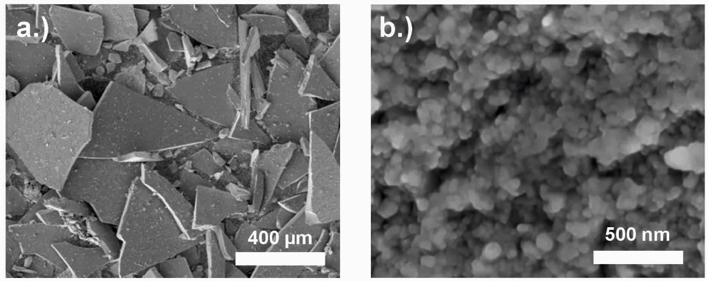
Figure 1: Nanocrystalline Nd-Fe-B powder (commercial MQU-F powder from the company Magnequench) made by melt-spinning a.) Macroscopic powder flakes b.) Nanocrystalline Nd₂Fe₁₄B grains. The different size of the scale bars is pointed out.

2.2 Pre-sintering of semi-dense compacts for SPT
Pre-sintering was done in a lab-scale FAST/SPS device (HP-D 5, FCT Systeme GmbH, Germany). Starting powder (15 g) was poured into a FAST/SPS graphite die (graphite type R7710, SGL Carbon GmbH, Germany) which had an internal diameter of 20 mm. Graphite foil with a thickness of 0.38 mm (type SIGRAFLEX, SGL Carbon GmbH, Germany) was used to line the die and punches in each process. FAST/SPS cycles were done with a heating rate of 100 K/min, a temperature of 500°C, a dwell time of 30 s and a pressure of 50 MPa resulting in pre-sintered pellets with a height around 8 mm and a relative density in the range of 70 – 75 % [Mishra 2023]. Figure 2 shows the pre-sintered form along with the stacking of the melt-spun powder particles after pre-sintering. Due to the localized heating where particles meet, sintering necks began to form, as can be seen in Figure 2c. Further microstructural development on the granular scale was otherwise avoided by the low processing temperature.

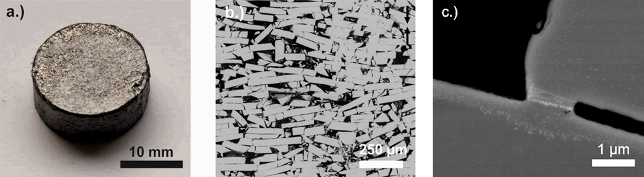
Figure 2: a.) Optical appearance of a Nd-Fe-B sample pre-sintered by FAST/SPS from melt-spun MQU-F powder (pre-sintering parameters 100 K⋅min⁻¹, 50 MPa, 500°C, 30 s), b.) Stacking of MQU-F powder within the pre-sintered compact, and c.) evidence of a sintering neck likely formed due to higher heat at particle contact points.

2.3 Pre-sintering of dense compacts for SPT
Hot-compaction of MQU-F was performed in FAST/SPS device HP-D10 (FCT Systeme GmbH, Germany), using a standard FAST/SPS graphite die (graphite type R7710, SIGRAFINE, SGL Carbon GmbH, Germany) with an inner diameter of 10 mm. A graphite foil with a thickness of 0.35 mm (type SIGRAFLEX, SGL Carbon GmbH, Germany) was inserted in the mold. Then, the mold was filled with 5 g of MQU-F powder, resulting in a 16 mm tall close-packed powder column (calculated tap density in the mold ca. 51 %).

Based on the experimental results obtained during the hot deformation (described in detail later in this manuscript), it was found out that residual porosity of the pre-sintered samples has negative impact on the microstructure evolution. Therefore, full densification of the pre-sintered compacts was aspired in this experimental series. Due to the limitations of the graphite tool with respect to the maximum applied pressure, the compaction temperature was gradually increased, while keeping the pressure below 50 MPa. To obtain fully dense samples without significant grain growth, dwell time at maximum temperature was kept at 60 s. In Figure 3, samples pre-sintered at 700°C, 725°C and 750°C are presented. At these temperatures, it was expected that formation of a transient liquid phase, as in the melting of the Nd-rich grain boundary, supported densification [Grieb 1992]. As shown in Figure 3a, at 700°C the sample has ca. 90% density, melt spun flakes are mostly aligned and no grain growth is observed (not visible in this magnification). The sample compacted at 725°C (Figure 3b) is fully dense with the melt spun flakes well aligned in whole sample volume with some grain growth observed. The sample compacted at 750°C (Figure 3c) was also fully dense, but abnormal grain growth already appeared at the boundaries of the former melt spun flakes. Grain growth at these points may be caused by powder particle contact points. At points where powder particles are in contact with each other, Joule heating is expected to lead to higher heat generation, therefore causing localized hot-spots that cause more developed grain growth than within the bulk [Mishra 2023]. Though this grain growth occurred, it was localized and not excessive. Based on these results, the compaction temperature was set to be 725°C. The optimal parameters for the FAST/SPS cycles were selected as follow: The contact pressure of 38 MPa was applied while the sample was heated up to 725°C with heating rate of 75 °C⋅min⁻¹. During the dwell time of 60 s the pressure was increased from 38 to 45 MPa. After processing the height of the pre-sintered pellets was found to be ca. 8 mm, which corresponds to a density of 100%, as determined by the Archimedes’ method.

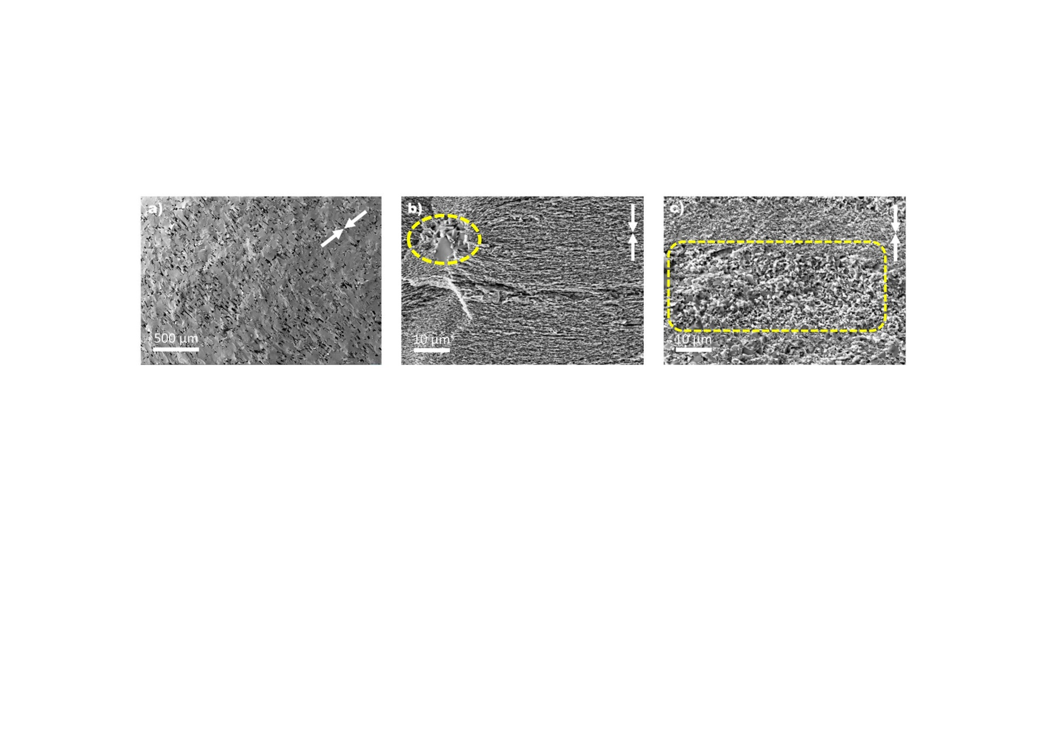
Figure 3: Fracture surface of a Nd-Fe-B sample pre-sintered by FAST/SPS from melt-spun MQU-F powder processed with heating rate of 75 K⋅min⁻¹, a pressure of 45 MPa and a dwelling time of 60 s at maximum temperature: a.) At 700°C, the sample has 90% of the theoretical density, porosity is visible, some ribbons are not aligned; b.) At 725°C, the sample has > 99% of the theoretical density, all ribbons are aligned, no significant grain growth; c.) At 750°C, the sample has 99% of the theoretical density, all ribbons are aligned, but grain growth is observed. Note the difference in the scale bar between a.) and the other two micrographs. The dotted line in Fig 5b and 5c indicates the areas where grain growth is observed.

2.4 Hot deformation of semi-dense compacts via SPT
SPT of the semi-dense compacts was performed to initiate anisotropic grain growth by rapid heating to deformation temperature under the pre-load required for operating the FAST/SPS device (10 kN). After achieving the aspired deformation temperature, the deformation load was applied, which varied between 50 and 500 MPa, followed by a short dwell time of 10 s. A specific focus of this experimental series was to investigate if high pressure supports the formation of pronounced microstructural texture, even in a semi-dense compact. In this experimental series, ∅ 20 mm samples pre-sintered at 500°C were placed in a ∅ 30 mm FAST/SPS tool, which was lined with a 0.38 mm thick graphite foil (type SIGRAFLEX, SGL Carbon GmbH, Germany). For the pressure of 50 MPa, the tool was made of graphite (graphite type R7710, SGL Carbon GmbH, Germany). For pressures > 50 MPa, a ∅ 30 mm tool made of the Mo-based alloy TZM (Plansee, Reutte, Austria) was used. The respective tool with the sample was mounted in the hybrid FAST/SPS device (H-HP-D25 SD/FL/MoSi, FCT Systeme GmbH, Germany) and the pre-load of 10 kN (= 32 MPa for a ∅ 20 mm sample) was applied. Then the sample was heated with a defined heating rate of 100 °C/min to the aspired deformation temperature. When achieving the temperature, the load was increased with a rate of approximately 32 kN⋅min⁻¹ to the aspired value. Then, after a constant holding time of 10 s, the sample was furnace cooled and the pressure released. Hot deformation of pre-sintered samples via FAST/SPS was carried out at different temperatures, heating rates and pressures. In all cases, sample diameter after deformation reached 30 mm, so wall friction due to the contact with the die might have influenced the height reduction in the final stage of deformation Table 1 summarizes the various parameter sets. In the T-series (T700-50, T750-50, T800-50), the hot deformation temperature was varied to 700, 750 and 800°C, while the pressure of 50 MPa was kept constant. In the P-series, the pressure was varied to 100, 200 and 500 MPa at a constant temperature of 800°C. These temperatures were chosen based on our former Flash SPS experiments, from which the 35 kW power pulse would lead to temperatures 800°C or higher during Nd-Fe-B deformation [Maccari 2023, Mishra 2023, Keszler 2023]. This result was then translated into the SPT parameters for comparison. Pressures higher than 50 MPa were tested to determine if an increase in pressure would lead to an increase in texture, with Nd-Fe-B grains experiencing a higher force to align their c-axis to the uniaxial pressure. For the current pulse ratio (CPR), we used the standard configuration of our FAST/SPS 12:2.

Table 1: FAST/SPS parameters used for hot deformation of porous Nd-Fe-B samples (pre-sintering parameters 500°C, 50 MPa, 10 min). Deformation and densification in relation to change of pressure, temperature, and heating rate.
Sample code | Heating rate [°C⋅min⁻¹] | Max. tempera-ture  [°C] | Pressure  [MPa] | Hold time  [s] | Height Reduction  [%] | Relative Density  [%]
T700-50 | 100 | 700 | 50 | 10 | 57.1 | 97
T750-50 | 100 | 750 | 50 | 10 | 59.3 | 97
T800-50 | 100 | 800 | 50 | 10 | 62 | 97
P800-100 | 100 | 800 | 100 | 10 | 60 | 98
P800-200 | 100 | 800 | 200 | 10 | 61 | 96
P800-500 | 100 | 800 | 500 | 10 | 65 | 99

2.5 Hot deformation of dense compacts via SPT
In parallel to the SPT deformation of semi-dense compacts, SPT deformation of dense compacts was performed. This was done to mirror the traditional hot-deformation process and determine the viability of SPT as an alternative form of hot deformation. The samples that were hot compacted by FAST/SPS using the optimized parameters as described in Section 2.1: 725°C and 45 MPa pressure. This led to a dense compact. Figure 4a shows a representative microstructure of a sample compacted under these conditions. For SPT, the ∅ 10 mm samples were placed in a ∅ 20 mm graphite tool (graphite type R7710, SIGRAFINE, SGL Carbon GmbH, Germany). Prior the SPT hot deformation, the hot compacted samples were sandblasted and sharp edges were removed to avoid damaging of the graphite pressing tools (Figure 4b). SPT hot deformation was carried out in the FAST/SPS device HP-D10 (FCT Systeme GmbH, Germany). A graphite foil (SGL Carbon, SIGRAFEX) with a thickness of 0.35 mm with an additional centering ring made of the same graphite foil. This was used to ensure the central placement of the specimen, guaranteeing homogeneous deformation. Differences in die choice and size reflect the tools available to the labs performing the experiments.

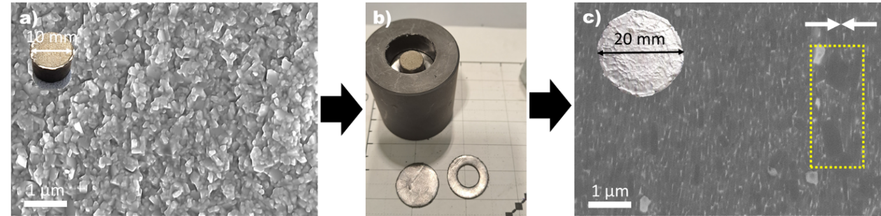
Figure 4: Overview of the SPT hot deformation process starting with a.) SEM image of a 10 mm dense hot compacted pellet with isotropic nanograin microstructure; b.) centering the pellet in a 20 mm graphite die; c.) SEM image of a 20 mm hot deformed sample (Parameters 750°C, 70 MPa, 60 s, sample code HDS 701) with anisotropic nanograined microstructure (grain growth can be observed in the area marked by the yellow dotted line).

The processing parameters for the hot deformation step were optimized aiming to obtain a well-pronounced, fiber- or brick-like texture while simultaneously avoiding abnormal/excessive grain growth. Based on the recent work of Sawatzki [Sawatzki 2016], the deformation temperature was set to be 750°C (25°C above the compaction temperature). The pre-load of 3kN (minimum required for the device) was applied, during which the sample was heated up to 600°C with a heating rate of 75 °C⋅min⁻¹. During the next step in the cycle, the sample was heated up to 725-750°C with 75 °C⋅min⁻¹, and pressure was increased to 50-80 MPa. The pressure was maintained at its maximum during the dwell time of 60 s at the maximum temperature of 725-750°C, which was followed by cooling, in which the power was switched off (see Table 2).

Table 2: FAST/SPS parameters investigated for the hot deformation of almost dense pre-sintered Nd-Fe-B compacts (pre-sintering parameters 725°C, 45 MPa, 60 s). Deformation and densification in relation to change of pressure, temperature, and heating rate.
Sample code | Heating rate [°C⋅min⁻¹] | Max. temperature  [°C] | Pressure  [MPa] | Hold time  [s] | Height Reduction  [%] | Relative Density  [%]
HDS 501 | 75 | 750 | 50 | 60 | 70 | 100
HDS 601 | 75 | 750 | 60 | 60 | 73 | 100
HDS 701 | 75 | 750 | 70 | 60 | 75 | 100
HDS 702 | 100 | 750 | 70 | 60 | 75 | 100
HDS 703 | 50 | 750 | 70 | 60 | 75 | 100
HDS 704 | 75 | 750 | 70 | 30 | 50 | 100
HDS 801 | 75 | 750 | 80 | 60 | 75 | 100
HDS 802 | 75 | 725 | 80 | 60 | 75 | 100

2.4. Characterization methods
The relative density was calculated based on the Archimedes principle (Sartorius Quintix224-1CEU balance with YDK03 option). For the calculation, a theoretical density of 7.55 g⋅cm⁻³ was used. Scanning electron microscopy (SEM) with a FEG-SEM JEOL JSM-7600 device (JEOL, Japan) and a Zeiss Merlin Field Emission Scanning Electron Microscope FEG-SEM (Carl Zeiss Microscopy GmbH) was used to characterize the microstructure depending on the processing conditions. Before microstructure characterization, all samples were broken into two halves. For investigation of microstructure on larger scale, one half was embedded in epoxy resin, ground with silicon carbide emery paper and then polished with water-free diamond suspensions down to 0.25 µm. The fractured surface of the other half was used for characterization of the primary nanocrystalline grains. (In the case of SPT of dense MQU-F samples, a rectangular piece was cut from the center of the sample for magnetic characterization. For SPT of semi-dense MQU-F samples, a half of the deformed sample was reserved for magnetic characterization.) For characterization of the magnetic behavior, a Permagraph C-300 system (MAGNET-PHYSIK Dr. Steingroever GmbH, Köln, Germany) was used.

3. Results
Table 3 summarizes the magnetic properties coercivity H_{cJ}, remanence B_{r} and energy-product (BH)_{max} of Nd-Fe-B magnets processed by the different field assisted sintering technologies starting from melt-spun powders. For benchmark, results from our former study [Mishra 2023] and related results from literature were included. It is to be noted that, in the latter case, MQU-F was not consistently the starting powder. Nevertheless, trends of how field assisted sintering parameters influence final microstructure and magnetic properties are obvious, enabling reliable conclusions about how to further optimize these technologies in future. As reference, magnetic properties of an MQU-F based die-upsetted magnet from a commercial water pump from the company WILO is considered as well. For exceeding the current industrial standard of anisotropic Nd-Fe-B magnets made by WILO, magnets should combine a coercivity higher than 1300 kA⋅m⁻¹ and a remanence higher than 1.3 T. For practical application, a high coercivity means that the permanent magnet is stable against demagnetization, e.g., when placing it in a magnetic field with opposite polarisation. A high remanence means that the magnet has a high permanent magnetization when the external magnetic field is turned to zero. In short, the magnet exerts a strong magnetic force without any external magnetic field. The stronger the magnetic force, the smaller the magnets can be designed, which is advantageous e.g., for high-performing electromotors with space limitations. For better interpretation of the results, some general relationships between microstructural features and magnetic properties are shortly summarized here [Croat 2018]. The coercivity is directly coupled with the size of the nanocrystalline grains and the interaction between grains. The highest coercivity is usually achieved in the as melt-spun starting powder and when the grains are magnetically decoupled by a Nd-rich grain boundary phase. For MQU-F powder, a coercivity of 1693 kA⋅m⁻¹ was measured. Onset of grain growth during magnet production is indicated by a decrease of the coercivity. The remanence is directly coupled with the amount of the main magnetic phase Nd₂Fe₁₄B in the sample volume and the texture of these grains. Non-magnetic secondary phases or residual pores lead to a decrease of the remanence. Furthermore, the remanence can be used as fingerprint for the anisotropy of the magnet. The maximum remanence of a fully isotropic Nd-Fe-B magnet is 0.8 T. Remanence values above 0.8 T indicate the onset of anisotropic grain growth and texture formation. High anisotropy is another tuning factor when aiming on compact magnet design. Last not least, the maximum energy product (BH)_{max} is the most important figure-of-merit for characterizing the general strength of a permanent magnet material. There are further microstructural features which influence the magnetic properties, but they are out of the scope and therefore not discussed in the present work.

Table 3: Height reduction, coercivity H_{cJ}, remanence B_{r} and energy product (BH)_{max} of Nd-Fe-B magnets processed by different field assisted sintering technologies starting from MQU-F powder in all cases. Results of this work are benchmarked with related results from literature. As reference, properties of MQU-F powder and a commercial magnet from WILO, Germany are shown (n.a. = not available, HD = hot deformation).
No. | Reference | Manufacturing route | Starting powder | Height reduction [%] | H_{cJ}  [kA⋅m⁻¹] | B_{r}  [T] | (BH)_{max}  [kJ⋅m⁻³]
1 | Commercial powder (Magnequench) | Melt-spinning | MQU-F | - | 1693 | 0.74 | 91
2 | Commercial magnet  (WILO) | Hot pressing | MQU-F | n.a. | 1569 | 0.83 | 120
3 | Commercial magnet  (WILO) | Hot pressing +  HD by die upsetting | MQU-F | n.a. | 1342 | 1.30 | 323
4 | Leich et al.  [Leich 2018] | Electro discharge sintering (EDS) | MQU-F | n.a. | 1565 | 0.78 | 102
5 | Liu et al.  [Liu 2010] | FAST/SPS  (630°C, 400 MPa, 3 min) | MQP-UG | n.a. | 1614 | 0.73 | 98
6 | Liu et al.  [Liu 2010] | FAST/SPS +  HD via FAST/SPS  (700°C, 400 MPa) | MQP-UG | 80 | 1004 | 1.49 | 400
7 | Wang et al.  [Wang 2015] | FAST/SPS  (650°C, 500 MPa, 3s) | MQP-F | n.a. | 1607 | 0.84 | 121
8 | Wang et al.  [Wang 2015] | FAST/SPS +  HD via FAST/SPS  (750°C, 500 MPa) | MQP-F | 70 | 1228 | 1.14 | 384
9 | Mishra et al.  [Mishra 2023] | FAST/SPS  (500°C, 50 MPa, 30 s) | MQU-F | n.a. | 1668 | 0.62 | 68
10 | Mishra et al.  [Mishra 2023] | FAST/SPS  (800°C, 50 MPa, 30 s) | MQU-F | n.a. | 1269 | 0.85 | 122
11 | This work  IWKS | FAST/SPS  (725°C, 48 MPa, 60 s) | MQU-F | 50 | 1648 | 0.83 | 123
12 | Castle et al.  [Castle 2017] | HD via Flash SPS  Pre-heating 450°C | MQU-F | n.a. | 1438 | 1.16 | 230
13 | This work  T700-50 | FAST/SPS + SPT  (700°C, 50 MPa, 10s) | MQU-F | 57 | 1243 | 1.05 | 197
14 | This work  T750-50 | FAST/SPS + SPT  (750°C, 50 MPa, 10s) | MQU-F | 59 | 1069 | 1.04 | 197
15 | This work  T800-50 | FAST/SPS + SPT  (800°C, 50 MPa, 10s) | MQU-F | 62 | 1087 | 1.11 | 215
16 | This work  P800-100 | FAST/SPS + SPT  (800°C, 100 MPa, 10s) | MQU-F | 60 | 1203 | 1.18 | 249
17 | This work  P800-200 | FAST/SPS + SPT  (800°C, 200 MPa, 10s) | MQU-F | 61 | 847 | 1.05 | 189
18 | This work  P800-500 | FAST/SPS + SPT  (800°C, 500 MPa, 10s) | MQU-F | 65 | 841 | 1.24 | 281
19 | This work  HDS701 | FAST/SPS + SPT  (750°C, 70 MPa, 60s) | MQU-F | 75 | 1180 | 1.38 | 305
20 | This work  HDS704 | FAST/SPS + SPT  (750°C, 70 MPa, 30s) | MQU-F | 50 | 1438 | 1.22 | 325

3.1 SPT of semi-dense compacts
All samples were pre-sintered via FAST/SPS at low temperature (500°C, 50 MPa, 30 s), to ensure that the growth of the nanocrystalline grains would be minimal enough to be neglected. This is confirmed by similar magnetic properties of MQU-F starting powder and pre-sintered samples (see Table 3). For initiating anisotropic grain growth, the pre-sintered samples were placed in the FAST/SPS, pre-loaded with 32 MPa and then heated with 100°C⋅min⁻¹ to the aspired temperature (700°C, 750°C, 800°C). Then, a higher load in the range of 50 – 500 MPa (related to the diameter of the pre-sintered compact) was applied to terminate the deformation. After reaching this load followed by a short dwell time of 10 s, the current was turned off.

As expected, densification improved with increase of temperature and increase of pressure (see Table 3). The lowest height reduction of 57 % occurred with sample T700-50, which had a maximum temperature of 700 °C. Since higher deformation degrees were obtained at 800 °C compared to 700 °C and 750 °C, with sample T800-50 obtaining the highest deformation of 62%, further deformation studies with varying pressure (100, 200, 500 MPa) were carried out at this temperature. Figure 5 shows the related deformation curves for the case of doing the main deformation step with a pressure of either 100 MPa (Figure 5a) or 500 MPa (Figure 5b). With increase of pressure, the height reduction increased between P800-100 and P800-500, from 60 to 65 % (Table 3). The black line in the graphs show the relative movement of the punch along with the deformation process. Deformation starts already under the pre-load at a temperature of around 500°C. When exceeding a temperature of around 650°C, deformation stops at a height reduction of around 50 %. The plateau of the deformation curve indicates the deformation of the samples to a degree, where contact to die walls and onset of wall friction appeared. When further increasing the load, deformation proceeds, but at a lower rate. Even in the cooling phase, where the load was released linearly, deformation still continues.

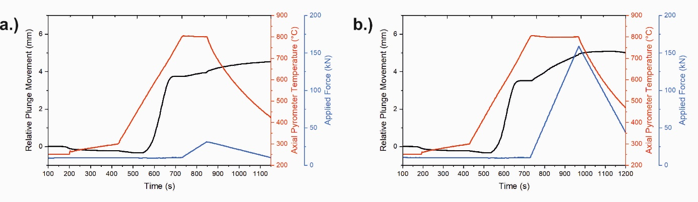
Figure 7: Hot deformation of pre-sintered, porous Nd-Fe-B samples (500°C, 50 MPa, 30s) via FAST/SPS. Pre-heating with 100°C⋅min⁻¹ to 800°C and pre-loading with 32 MPa before applying the main pressure of a.) 100 MPa (P800-100) b.) 500 MPa (P800-500). The pressure is related to the initial sample diameter of 20 mm).

In this experimental approach, the highest remanence value 1.24 T was obtained from the sample P800-500 with the maximum applied pressure of 500 MPa. Comparisons of J-H curves can be seen in Figure 6. In addition, the highest density and the largest height reduction were obtained as well. This result indicates that in general hot deformation at high pressure is advantageous for texturing the grains, therefore achieving pronounced anisotropic magnetic properties. Similar trends were observed in the literature [Liu 2010, Wang 2015]. Nevertheless, heating with 100°C⋅min⁻¹ to the aspired deformation temperature followed by another dwell time at this temperature until the main deformation load is achieved took obviously too long to reliable avoid onset of anomalous grain growth. This assumption is confirmed within the given microstructures (Figure 7). Even after the deformation step, clear boundaries of the starting MQU-F powder particles are visible in the form of bright Nd-rich outlines. Likely these do not dissolve due to the presence of oxygen on the surface of the particles. Though it is possible for oxides to be burned off of metal powders during FAST/SPS, this does not seem to have happened in this case [Chawake 2014]. Large amounts of anomalous grains with sizes in the several micrometer range are a clear indicator for explaining the low coercivity values. It is interesting to note that at a given temperature (800°C) grain growth becomes more enhanced at the higher pressure. For taking advantage of high pressure and, at the same time, avoiding anomalous grain growth, direct application of the high load seems to be the preferred option, but sufficient stability of the pre-sintered, porous compacts is questionable in this case. Additional improvements can be made through the tailoring of deformation speeds to avoid crack formation in the final sample [Hinz 2003]. The best combination of coercivity and remanence can be seen in sample P800-100 (H_{cJ} = 1203 kA/m, B_{r} = 1.18 T). This is likely due to the combination of the temperature being optimal for anisotropic grain development among the melted grain boundary phase, as stated by Hioki et al. [Hioki 2021]. However, as mentioned before, Joule heating hot spots at particle contact points could lead to excessive grain growth – therefore, surface contact of the MQU-F particles at the setpoint temperature of 800 °C likely caused undesired grain growth and negatively affected coercivity. Despite the excessive grain growth, sample P800-500 still achieved the highest (BH)_{max}, 281 kJm⁻³, of all semi-dense deformed samples, due to its density and texture influencing its B_{r}. The additional pressure in the samples of P800-200 and P800-500 likely led to greater mass transfer and thus more excessive grain growth, despite the higher pressure leading to a more optimal texture.
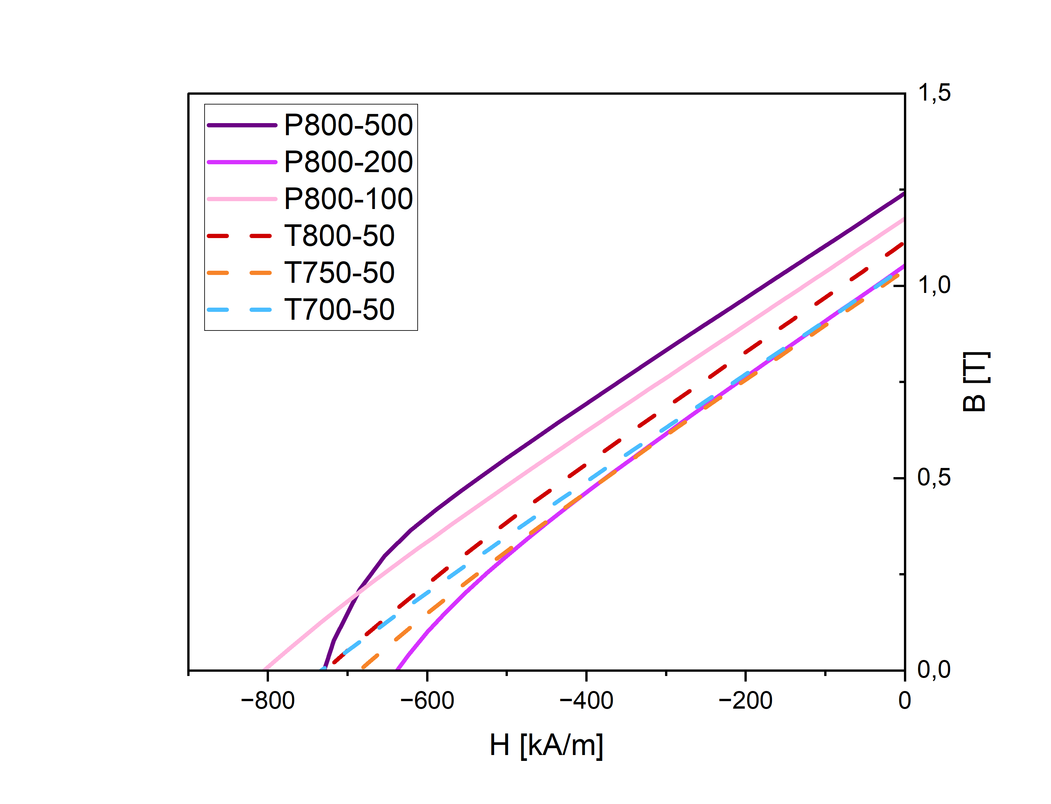
Figure 6: J-HB-H curves (2nd quadrant) of samples P800-100, P800-200, and P800-500, P800-500, T800-50, T750-50, and T700-50.

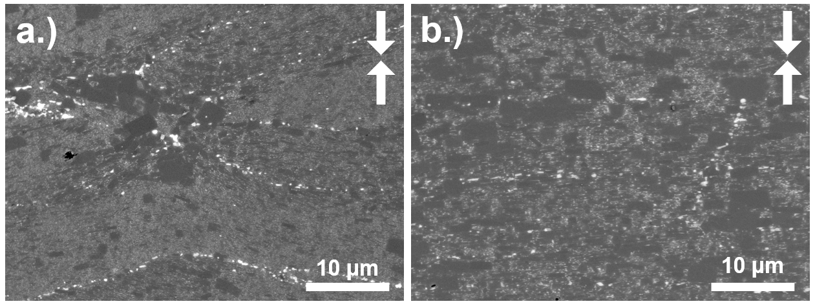
Figure 7: SEM cross-sections of SPT samples deformed at given heating rate (100°C⋅min⁻¹) and temperature (800°C), but different maximum pressure a.) 100 MPa (P800-100) and b.) 500 MPa (P800-500). The sample P800-100 deformed at 100 MPa displays significantly less alignment than the sample P800-500 deformed at 500 MPa. The sample P800-500 also displays much larger grains. The pressing direction is marked with white arrows.

3.2 Hot deformation of pre-sintered, dense compacts by FAST/SPS
The sample HDS501 produced with a maximum temperature of 750°C and maximum pressure of 50 MPa had a final diameter of 19 mm. Therefore, the sample did not fully deform to the 20 mm diameter of the die used for deformation. This inadequate deformation caused the sample to not be well-deformed at the edge, where cracks were visible. Consequently, the degree of alignment was inhomogeneous at the outer part of the sample. Contrarily, a homogeneous microstructure was observed in the center. To complete the deformation and improve the microstructure with respect to the texture, the pressure during the dwell time of 60 s at 750°C was further increased to 60 MPa (sample series HDS60x), 70 MPa (sample series HDS70x) and 80 MPa (sample series HDS80x), while keeping the cooling conditions constant.

By increasing the applied pressure, a significant improvement on the alignment was obtained, however grain growth was observed. This is in agreement with the experimental series SPT of semi-dense Nd-Fe-B compacts in section 3.1, though the scale of pressure increases was in the range of the tens of MPa as opposed to the hundreds. Likely grain growth could be attributed to increased mass transfer along the liquified Nd-rich grain boundary phase under increased pressure. As summarized in Table 2, further deformation experiments were done by varying the heating rate (50 to 100 °C⋅min⁻¹) and the dwelling temperature (30 s and 60 s). Based on the observed microstructures, the best results were obtained for the sample HDS 701 with the heating rate of 75 °C⋅min⁻¹, a pressure of 70 MPa and a dwell time of 60 s at 750°C. Under these conditions, a nano grained microstructure with well aligned grains resulted (see Figure 4c).

This deformation of dense compacts is an approach is in accordance with established magnet production by hot pressing and die-upsetting [Croat 2018]. Figure 8 shows exemplarily the FAST/SPS cycles used for production of hot compacted, dense semi-finished parts (Figure 8a) and the SPT hot deformed (Figure 8b) sample HDS 701. For the SPT hot deformation, contact pressure of 10 MPa (calculated for the 20 mm die) was applied and temperature was increased up to 750 °C with heating rate of 75 °C⋅min⁻¹. Once the sample temperature reached 600°C, pressure and temperature were increased simultaneously until reaching 50 MPa at 750°C. The pressure was further increased during the 60 seconds dwelling step at 750°C (See Figure 8).

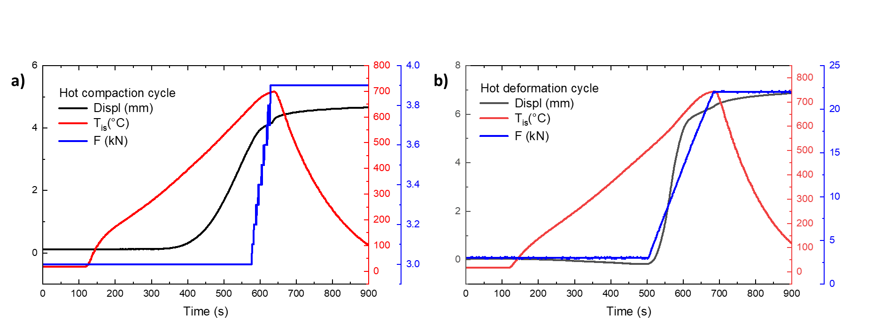
Figure 8: a.) Hot compaction (= pre-sintering) cycle of a dense semi-finished sample (725°C, 48 MPa, 60s) via FAST/SPS. b.) Hot deformation cycle of dense Nd-Fe-B samples: Pre-heating with 75°C⋅min⁻¹ to 600°C and pre-loading with 10 MPa before applying the main pressure of 70 MPa and temperature of 750°C (Sample HDS 701).

The pressure during the dwelling step was varied between 50 and 80 MPa in order to obtain better deformation and alignment of the nanocrystalline grains as shown in Figure 4. Based on the obtained results, it was found, that the pressure of 50 MPa (sample HDS 501) is not enough to fulfil the deformation (only 70% height reduction by aimed 75%). The sample obtained at 50 MPa has well-aligned microstructure in the center, but high degree of misalignment and cracks in the outer edge area. The sample HDS 601 obtained with 60 MPa applied pressure has 73 % height reduction and well-aligned microstructure in most of the volume with small misalignment areas close to the edge. The sample HDS 701 obtained with 70 MPa applied pressure has 75 % height reduction and well-aligned microstructure in the whole sample volume, while the grain growth remains on a low level (see Figure 9a). The sample HDS 801 obtained with 80 MPa applied pressure at 750°C shows a well-aligned but coarsened microstructure due to accelerated grain growth possibly enhanced by the improved grains contact and thermal conductivity. Sample HDS 802 hot deformed with 80 MPa at lower temperature (see Table 2, sample HDS802) demonstrates that grain growth can be controlled by the proper selection of the processing parameters. In agreement with the SPT of semi-finished, dense Nd-Fe-B compacts, there seems to be a zone around 80-100 MPa of applied pressure and maximum temperature of 750-800 °C where texturing occurs without excessive grain growth, leading to the best combination of H_{cJ} and B_{r}. Extending into higher pressures at these temperatures, however, is expected to cause excessive grain growth despite the development of well-aligned texture.

To understand the correlation between the initial sample density and the resulting microstructure, hot deformation was also performed on a pre-sintered sample with only 90 % density (see related microstructure before hot deformation in Figure 3a). As reference, the microstructure of sample HDS 701 hot deformed at 750°C, 70 MPa starting from a dense, semi-finished part is shown in Figure 9a. In sample HDS 701, the alignment of the nanocrystalline grains (indicated by black arrows) is perpendicular to the pressing direction (indicated by white arrows) and parallel in both neighboring flakes. Grain growth is observed in the boundary area of former powder flakes (indicated by dotted lines). Figure 9b represents the microstructure of a sample hot deformed with the same parameters (750°C, 70 MPa), but starting from a semi-finished part with a density of only 90 %. The two neighboring flakes have well aligned nanocrystalline grains, however these are not always perpendicular to the pressing direction and parallel to each other. It is possible that, during the deformation process, the flakes adjacent to the pores do not rotate and slide parallel to the other flakes as described above, but preferably slide into the empty pore space with a rather random orientation. This can explain why optimal alignment is not seen in SPT samples of semi-dense compacts at similar deformation pressures, as described in the previous section 3.1. In an attempt to improve the orientation of such flakes, a hot compacted sample with 90% density was hot deformed at 750°C, 80 MPa, and the obtained microstructure is shown in Figure 9c. As it can be seen, the alignment of the nanocrystalline grains in the two neighboring flakes are again parallel to each other and perpendicular to the pressing direction. However, the flake boundary area is now broader and the nanocrystalline grains are also bigger due to the ongoing grain growth processes.

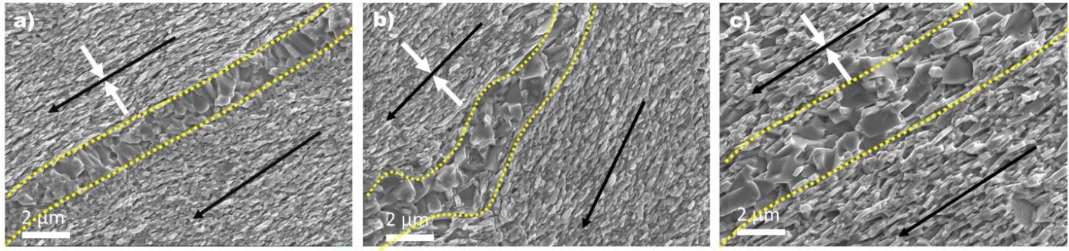
Figure 9: Influence of the hot compacted sample density on the microstructures of hot deformed sample: a.) dense hot compacted sample HDS 701 hot deformed at 750°C, 70 MPa; b.) 90 % hot compacted sample hot deformed at 750°C, 70 MPa; c.) 90 % hot compacted sample hot deformed at 750°C, 80 MPa; The white arrows indicate the pressing direction. Black arrows indicate the alignment direction. The dotted lines indicate the area of grain growth.

3.4 Benchmark of Nd-Fe-B SPT
The SPT hot deformation experiments conducted at Forschungszentrum Jülich (marked in Figure 10 with green color) are still quite preliminary in nature. Even though a high densification of around 96 % at with sample T700-50 was achieved, the magnetic properties remained predominantly isotropic, suggesting the absence of texture. Increasing the temperature to 800°C while keeping the pressure of 50 MPa constant slightly improved the remanence, but significant decrease of coercivity indicated the onset of anomalous grain growth. Increasing the pressure to 500 MPa further increased the remanence to 1.25 T, but longer dwell time at 800°C for achieving this pressure were counterproductive for the coercivity. The results indicate the expected positive influence of high pressures for microstructure texturing, but the applied temperature of 800°C was too high to reliably avoid anomalous grain growth. The increased grain growth at higher pressure is a phenomenon, which is not fully understood and therefore requires further investigations. It is possible that a combination of a lower temperature (such as 700-750°C) combined with high pressure could be a parameter set of interest. As particle contacts tend to heat up more due to Joule heating, localized Nd-rich grain boundary liquification could lead to a more controlled mass transfer than with an 800°C setpoint. Likely the samples processed at 800°C were experiencing higher temperatures between particles than the bulk, therefore leading to larger grains.

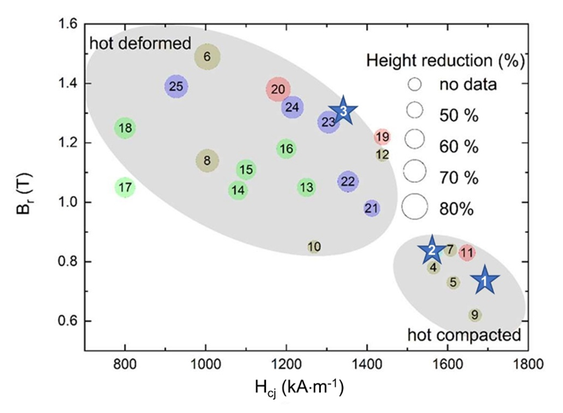
Figure 10: Magnetic properties of Nd-Fe-B magnets made by FAST/SPS starting from melt-spun powders. The numbers are the consecutive numbers given in Table 3. Green color stands for the T- and P-series of Forschungszentrum Jülich; Red color stands for the HDS-series of Fraunhofer IWKS; Blue color stands for the F35-series of Forschungszentrum Jülich. The influence of the deformation degree on magnetic properties is pointed out. For reference, the values of the starting MQU-F powder (labelled as 1) and the commercial magnets from WILO (2 for hot compacted, 3 for hot deformed) are shown as star symbols.

Significantly better results were achieved in the SPT attempts done at Fraunhofer IWKS, where dense compacts were used for hot deformation. These SPT hot deformed samples can fully deform to the diameter of the outer die with crack-free edges only if a sufficient height reduction is achieved. Further investigations on the height reduction on the microstructure and the magnetic properties should be carried out in the future, as this work is preliminary in SPT optimization. Despite the scale of pressure increase being an order of magnitude lower than the SPT of the semi-dense compacts, grain growth was still observed. The best observed results were from HDS701, which was SPT hot deformed at 70 MPa, 750°C with a height reduction of 75 %. The magnet had a B_{r} = 1.38 T, H_{cJ} = 1180 kA⋅m⁻¹, and (BH)_{max} = 305 kJ⋅m⁻³. This varies from the best performing SPT semi-dense samples, such as T750-50 (62% height reduction, B_{r} = 1.11 T, H_{cJ} = 1087 kA⋅m⁻¹, and (BH)_{max} = 215 kJ⋅m⁻³) and P800-100 (60% height reduction, B_{r} = 1.18 T, H_{cJ} = 1203 kA⋅m⁻¹, and (BH)_{max} = 249 kJ⋅m⁻³). Significant differences in magnetic behavior between SPT samples deformed at similar parameters, such as HDS701 and T750-50, may be attributed to several reasons. For magnetic characterization, in the case of HDS701, a rectangular piece was cut from the center of the sample and measured. T750-50, however, was half of a circular sample. The effect of this cutting likely caused variation in remanence. While the remanence of T750-50 is expected to be somewhat lower than in the case of HDS701 due to a 20 MPa difference in deformation pressure, the inclusion of more of T750-50’s edge in magnetic characterization likely affected the remanence as well, as undoubtedly the edge was less dense than the center of the sample. Degree of deformation between semi-dense and dense compacts also carries different implications, as semi-dense compacts contain more space to be overcome between the particles during the SPT deformation. Difference in starting sample mass, diameter, and deformation diameter may also have an effect on the final magnetic performance. Experiments that normalize the amount of deformation relative to the starting mass are necessary for complete direct comparison between methods.

In Figure 11, the development of the magnetic performance of the best performing samples of the HDS series at the different processing stages are presented. The magnetic properties of the initial MQU-F powder were measured using spherical specimens of isotropic powder consolidated and mixed with 5 wt. % of epoxy resin. The magnetic performance of all other samples shown was measured using rectangular specimens, cut from the sample center. All curves were corrected with their corresponding demagnetization factor. The step-like change in the magnetization loop of the initial isotropic MQU-F powder indicates the presence of a certain amount of amorphous grains phase. The magnetization curve of the hot deformed sample indicates that, during the hot compaction prior to SPT deformation, the amorphous grains also transform into a nanocrystalline microstructure (as indicated by Figure 11a) while still remaining isotropic. As a result, the coercivity is slightly improved, while the saturation magnetization remains unchanged. The latter confirms that grain growth during the compaction process was avoided. During the subsequent hot deformation process, anisotropy is induced by the deformation and alignment of the nanocrystalline grains (see Figure 9). As result of hot deformation, in the case of sample HDS 701 the coercivity is reduced by ca. 20%, while the remanence is increased by ca. 32%. These values are connected with the degree of deformation defined by sample height reduction during SPT. In Figure 11b, the magnetization loops are displayed for samples with different height reductions produced by SPT in the present work (selected samples from the HDS-series) and compared with conventionally hot-pressed samples from the work of Sawatzki [Sawatzki 2016]. As it can be seen, the SPT samples have the same performance (Sample HDS 704: B_{r} = 1.22 T, H_{cJ} = 1438 kA⋅m⁻¹, and (BH)_{max} = 305 kJ⋅m⁻³ and sample HDS 701: B_{r} = 1.38 T, H_{cJ} = 1180 kA⋅m⁻¹, and (BH)_{max} = 325 kJ⋅m⁻³ for 50 and 75 % height reduction) as the conventionally hot-pressed samples, but with a significantly higher degree of deformation. This effect could be of interest from an application standpoint but requires further investigation. One possible explanation for the different deformation behavior could be the different way how pressure is applied during both processes. In our SPT approach, the applied pressure is constantly increasing, while in hot-pressing, the pressure was applied in a way ensuring a constant displacement speed and therefore constant deformation rate.

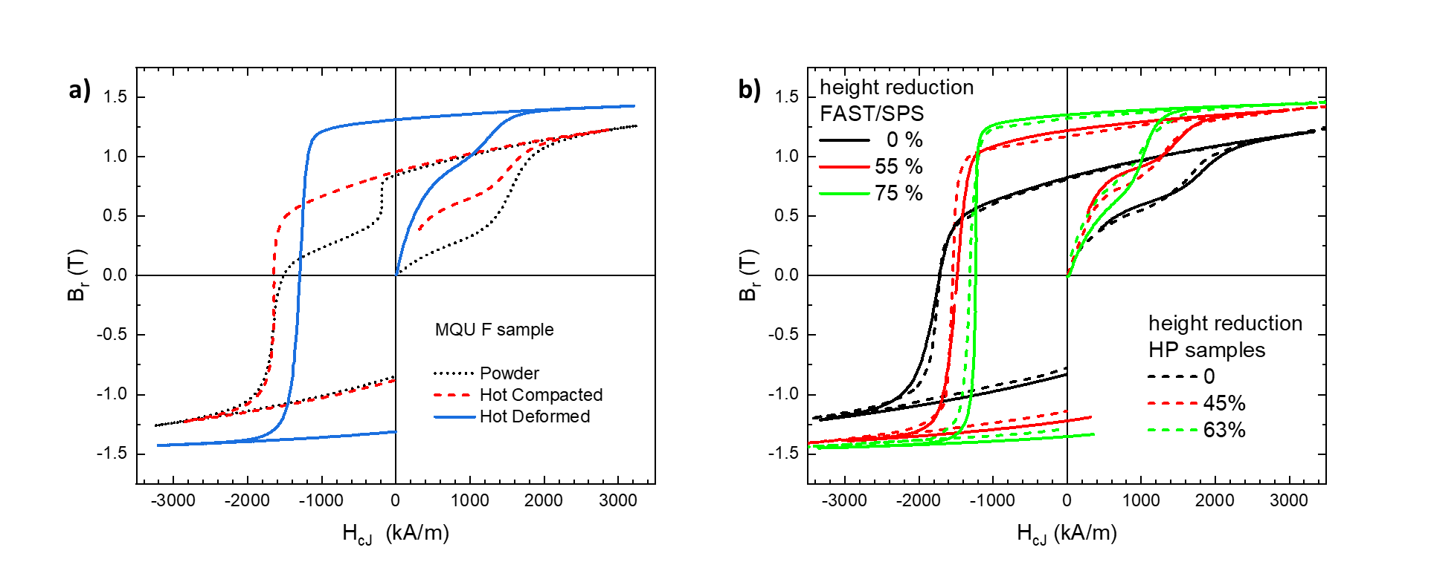
Figure 12: Magnetization curves of samples made from melt-spun MQU-F powder a.) Change of magnetization behavior during the different processing stages b.) Comparison of magnetization behavior of Nd-Fe-B magnets made by FAST/SPS (HDS-series) and HP [Sawatzki 2016]. The differences in height reduction for both techniques resulting in similar magnetic properties are pointed out.

In the literature, the best results of hot deformation by SPT were achieved by Liu et al. [Liu 2010] and Wang et al. [Wang 2015]. Liu et al. performed SPT hot-deformation on a MQP-UG powder at 400 MPa and 700°C, achieving a height reduction of 80 %. The magnetic performance of this sample was B_{r} = 1.492 T, H_{cJ} = 1004 kA⋅m⁻¹, and (BH)_{max} = 400 kJ⋅m⁻³. It should be noted that in this study, samples for magnetic performance were taken from the center of the magnet and did not include the magnet edge. Optimally this magnetic performance would be homogenous throughout a full SPT magnet. However, as the edge was not tested in this study, information regarding sample homogeneity is unknown.

Wang et al. performed the hot deformation of a MQP-F powder at 500 MPa and 700°C, resulting in a height reduction of 70 %. The authors reported magnetic properties of B_{r} = 1.14 T, H_{cJ} = 1227.9 kA⋅m⁻¹, and (BH)_{max} = 383.9 kJ⋅m⁻³. In the study of Wang et al., it has been demonstrated that the current pulse ratio (CPR) is an additional influence factor for tuning the magnetic properties. Magnets prepared with a CPR of 2:2 (= pulse length of 6.6 ms) outperformed the performance of magnets prepared with a CPR of 12:2 (= pulse length 39.6 ms). In the latter case, the properties were slightly lower with B_{r} = 1.11 T, H_{ci} = 1205.6 kA⋅m⁻¹, (BH)_{max} = 352.2 kJ⋅m⁻³. The authors argued that the amount of partial liquid phase during deformation is reduced with shorter pulse length reducing the decomposition of the Nd₂Fe₁₄B phase during hot deformation. Though change in CPR was not conducted in this work, it adds another layer of possibility for fine-tuning parameters to produce optimized SPT magnets. When benchmarking the results of Liu et al. [Liu 2010] and Wang et al. [Wang 2015], it must be considered that powders from MQP series were used as starting materials, which are –according to the manufacturer Magnequench – usually applied for bonded magnets and not optimized for hot deformation [Magnequench 2024].

4. Conclusions
Our results reveal that Nd-Fe-B magnets, which were hot deformed by spark plasma texturing (SPT), approach or even exceed the properties of some commercial anisotropic Nd-Fe-B magnets. The best performance was achieved with a SPT-deformed dense magnet, sample name HDS701 which was pre-sintered to almost theoretical density by FAST/SPS (75 K⋅min⁻¹, 725°C, 45 MPa, 1 min) and then SPT hot deformed at 70 MPa, 750°C with a height reduction of 75 %. The magnet had a B_{r} = 1,38 T, H_{cJ} = 1180 kA⋅m⁻¹, and (BH)_{max} = 305 kJ⋅m⁻³. A specific challenge of FAST/SPS devices is the need of applying a pre-load to ensure sufficient electrical contact. Therefore, samples must be necessarily pre-sintered when conducting hot-deformation in a FAST/SPS device. Our study reveals that pre-sintering to almost theoretical density is – similar to conventional magnet production by hot pressing and die-upsetting – preferred for achieving homogeneous deformation and reliably avoiding cracks at the edges. Another challenge is the avoidance of anomalous grain growth during pre-sintering as well as during hot deformation. The risk of anomalous grain growth is significantly enhanced if the FAST/SPS temperature exceeds 700°C in either hot compaction or SPT hot deformation. Contrarily, temperatures beyond 700°C are advantageous for full densification in the shortest possible time. Therefore, fine tuning of temperature and dwell time is an absolute must. Our studies show the influence applied pressure has on promoting anisotropic grain growth. The observation that higher pressures even accelerate grain growth requires further investigation.

Though the highest magnetic performance was not observed with an SPT-deformed semi-dense magnet, room for parameter adjustment and optimization exists. The benefit of minimizing grain growth with a 500°C pre-sinter phase is the potential processing of anisotropic magnet scrap in the matrix. Future investigations will continue with both optimizing the low-temperature, semi-dense route with gradual introduction of crushed recycled magnetic scrap. Potentially SPT hot deformation of these semi-dense mixed-recycled compacts at high enough temperature could also induce grain rotation in the anisotropic scrap to align grain c-axis with the uniaxial pressing force. Nevertheless, further work is needed before this can be achieved.

Acknowledgements
This work was supported by the German Research Foundation (DFG) under the grant numbers BR3418/1-2 and GU514/8-2. Furthermore, parts of the work were done in the framework of the project “EnerGieeffiziENtE KreiSlaufwirtschaft krItischer RohStoffe GENESIS” funded by the German Ministry of Economic Affairs and Climate Action (BMWK), Förderkennzeichen 03EI5009D according to a decision of the German Federal Parliament. The work performed at Fraunhofer IWKS and TU Darmstadt was supported by BMWK in the frame of the RecycleTeam project. The funding and the experimental support of Ralf Steinert are highly acknowledged.

Authors contributions
M. Kezler: Experimental work at Forschungszentrum Jülich, writing and revision of manuscript; I. Radulov: Funding acquisition, experimental work at Fraunhofer IWKS, writing and revising; F. Maccari: Characterization and interpretation of the magnetic results; T. Mutuk: Hot deformation by FAST/SPS at high pressure; M. Krengel: Magnetic measurements on selected samples; O. Guillon: Supervision of the work at Forschungszentrum Jülich, discussion of results; O. Gutfleisch: Funding acquisition, supervison of the work at Fraunhofer IWKS and TU Darmstadt, discussion of results; M. Bram: Funding acquisition, supervision, writing first draft of manuscript.

References
[Castle 2017] E. Castle, R. Sheridan, W. Zhou, S. Grasso, A. Walton, M.J. Reece, High coercivity, anisotropic, heavy rare earth-free Nd-Fe-B by Flash Spark Plasma Sintering, Sci. Rep. 7 (2017) 11134.
[Chawake 2014] N. Chawake, L. D. Pinto, A. K. Srivastav, K. Akkiraju, B.S. Murty, R. S. Kottada, On Joule heating during spark plasma sintering of metal powders, Scripta Materialia 93 (2014) 52-55.
[Croat 1984] J.J. Croat, J.F. Herbst, R.W. Lee, F.E. Pinkerton, Pr-Fe and Nd-Fe based materials: a new class of high-performance permanent magnets, J. Appl. Phys. 55 (1984) 2078 – 2082.
[Croat 2018] J.J. Croat, Rapidly Solidified Neodymium-Iron-Boron Permanent Magnets, Woodhead Publishing Series in Electronic and Optical Materials, Elsevier, 2018.
[Fais 2023] A. Fais, Electro-Sinter-Forging: Advances and prospects of the fastest FAST, Presentation on 23th FAST/SPS expert meeting, Nov 11, 2023, Villaz-St-Pierre, Switzerland.
[Gopalan 2009] R. Gopalan, H. Sepehri-Amin, K. Suresh, T. Ohkubo, K. Hono, T. Nishiuchi, N. Nozawac, S. Hirosawa, Anisotropic Nd–Fe–B nanocrystalline magnets processed by spark plasma sintering and in situ hot pressing of hydrogenation–decomposition–desorption–recombination powder, Scripta Mat. 61 (2009) 978 – 981.
[Grasso 2014] S. Grasso, T. Saunders, H. Porwal, O. Cedillos-Barraza, D. D. Jayaseelan, W.E. Lee, M.J. Reece, Flash Spark Plasma Sintering (FSPS) of Pure ZrB₂, J. Am. Ceram. Soc. 97 (2014) 2405 – 2408.
[Grieb 1992] B. Grieb, E.-Th. Henig, G. Schneider, G. Knoch, G. Petzow, D. de Mooij, Powder Metall. 35 (1992) 221 – 227.
[Grünberger 1997] W.Grünberger, D.Hinz, A.Kirchner, K.H.Müller, L.Schultz, Hot deformation of nanocrystalline Nd-Fe-B alloys, J. Alloy. Compd. 257 (1997) 293–301.
[Gutfleisch 2000a] O. Gutfleisch, Controlling the properties of high energy density permanent magnetic materials by different processing routes, J. Phys. D 33 (2000) R157–R172.
[Gutfleisch 2000b] O. Gutfleisch, D. Eckert, R. Schäfer, K. H. Müller, Magnetization processes in two different types of anisotropic, fully dense NdFeB hydrogenation, disproportionation, desorption, and recombination magnets, J. Appl. Phys. 87 (2000) 6119-6121.
[Gutfleisch 2011] O. Gutfleisch, M.A. Willard, E. Brück, C.H. Chen, S.G. Sankar, J. Ping Liu, Magnetic Materials and Devices for the 21st Century: Stronger, Lighter, and More Energy Efficient, Adv. Mater. 23 (2011) 821–842.
[Hinz 2003] D. Hinz, A. Kirchner, D.N. Brown, B.M. Ma, O. Gutfleisch, Near net shape production of radially oriented NdFeB ring magnets by backwards extrusion, Journal of Materials Processing Technology 135 (2003) 358-365.
[Hioki 2021] K. Hioki, High performance hot-deformed Nd-Fe-B magnets (Review), Sci. Techn. Adv. Mat. 22 (2021) 72 – 84.
[Hu 2011] Z. Hu, L. Chu, J. Li, Y. Liu, Enhanced magnetic properties in Nd-Fe-B magnets prepared by spark plasma sintering via die-upsetting process, Journal of Rare Earths 29 (2011) 660 – 663.
[Huang 2012] Y.L. Huang, Z.W. Liu, X.C. Zhong, H.Y. Du, D.C. Zeng, NdFeB based magnets prepared from nanocrystalline powders with various compositions and particle sizes by spark plasma sintering, Powder Metall. 55 (2012) 124–129.
[Ikram 2019] A. Ikram, M. Farhan Mehmood, M. Podlogar, A. Eldosouky, R.S. Sheridan, M. Awais, A. Walton, M. Macek Krzmanc, T. Tomse, S. Kobe, S. Sturm, K. Zuzek Rozman, The sintering mechanism of fully dense and highly coercive Nd-Fe-B magnets from recycled HDDR powders reprocessed by spark plasma sintering, J. Alloys Comp. 774 (2019) 1195 – 1206.
[Ikram 2020] A. Ikram, M. Awais, R. Sheridan, A. Walton, S. Kobe, F. Pusavec, K. Zuzek Rozman, Spark plasma sintering as an effective texturing tool for reprocessing recycled HDDR Nd-Fe-B magnets with lossless coercivity, Metals 10 (2020) 418.
[Keszler 2023] M. Keszler, F. Grosswendt, A.-C. Assmann, M. Krengel, F. Maccari, O. Gutfleisch, D. Sebold, O. Guillon, S. Weber, M. Bram, Direct recycling of Nd-Fe-B magnet scrap by field assisted sintering technologies, Adv. Energy Sustainability Res. (2023) 2300184.
[Khlopkov 2004] K. Khlopkov, O. Gutfleisch, R. Schäfer, D. Hinz, K.-H. Müller, L. Schultz, Interaction domains in die-upset NdFeB magnets in dependence on the degree of deformation, Journal of Magnetism and Magnetic Materials 272-276 (2004) E1937 – E1939.
[Khlopkov 2007] K. Khlopkov, O. Gutfleisch, D. Hinz, K.-H. Müller, L. Schultz, Evolution of interaction domains in textured fine-grained Nd₂Fe₁₄B magnets, J. Appl. Phys. 102 (2007) 023912.
[Kirchner 1998] A. Kirchner, W. Grünberger, O. Gutfleisch, V. Neu, K. H. Müller, L Schultz, A comparison of the magnetic properties and deformation behaviour of Nd-Fe-B magnets made from melt-spun, mechanically alloyed and HDDR powders, J. Phys. D: Appl. Phys. 31 (1998) 1660-1666.
[Kirchner 2000] A. Kirchner, D. Hinz, V. Panchanathan, O. Gutfleisch, K. H. Müller, L Schultz, Improved hot workability and magnetic properties in NdFeCoGaB hot deformed magnets, IEEE Transactions of Magnets 36 (2000) 3288-3290.
[Lee 1985] R.W. Lee, Hot-pressed neodymium-iron-boron magnets, Appl. Phys. Letters 46 (1985) 790 – 791.
[Leich 2018] L. Leich, A. Röttger, W. Theisen, M. Krengel, Densification of nanocrystalline NdFeB magnets processed by electro-discharge sintering – Microstructure, magnetic, and mechanical properties, J. Magn. Magn. Mat. 460 (2018) 454–460.
[Leich 2019] L. Leich, A. Röttger, M. Krengel, W. Theisen, Recycling of NdFeB Magnets by Electrodischarge Sintering—Microstructure, Magnetic, and Mechanical Properties, J. Sustain. Metall. 5 (2019) 107-117.
[Liu 2010] W. Q. Liu, Z. Z. Cui, X. F. Yi, M. Yue, Y. B. Jiang, D. T. Zhang, J. X. Zhang, X. B. Liu, Structure and magnetic properties of magnetically isotropic and anisotropic Nd–Fe–B permanent magnets prepared by spark plasma sintering technology. J. Appl. Phys. 107 (2010) 09A719.
[Liu 2012] Z.W. Liu, Y.L. Huang, H.Y. Huang, X.C. Zhong, H.Y. Yu, D.C. Zeng, Isotropic and Anisotropic Nanocrystalline NdFeB-Based Magnets Prepared by Spark Plasma Sintering and Hot Deformation. Key Eng. Mat. 510 – 511 (2012) 307 – 314.
[Liu 2013] J. Liu, H. Sepheri-Amin, T. Ohkubo, K. Hioki, A. Hattori, T. Schrefl, K. Hono, Effect of the Nd content on the microstructure and coercivity of hot-deformed Nd-Fe-B permanent magnets, Acta Mat. 61 (2013) 5387 – 5399.
[Magnequench 2024] Magnequench, https://mqitechnology.com/products, accessed 12 January 2024.
[McGuiness 1992] P.J. McGuiness, C. Short, A.F. Wilson, I.R. Harris, The production and characterization of bonded, hot-pressed and die-upset HDDR magnets, J. Alloys Comp. 184 (1992) 243 – 255.
[Mishra 1988] R.K. Mishra, E.G. Brewer, R.W. Lee, Grain growth and alignment in hot deformed Nd-Fe-B magnets. J Appl Phys. 63 (1988) 3528–3530.
[Mishra 1990] R.K. Mishra, T.Y. Chu, L.K. Rabenberg, The development of the microstructure of die-upset Nd-Fe-B magnets, J. Magn. Magn. Mater. 84 (1990) 88–94.
[Mishra 2023] T. Prasad Mishra, L. Leich, M. Krengel, S. Weber, A. Röttger, M. Bram, NdFeB Magnets with Well-Pronounced Anisotropic Magnetic Properties Made by Electric Current-Assisted Sintering, Adv. Eng. Mat. 25 (2023) 2201027.
[Nakayama 1993] R. Nakayama, T. Takeshita, Nd-Fe-B anisotropic magnet powders produced by the HDDR process, Journal of Alloys and Compounds, 193 (1993) 259-261.
[Noudem 2012] J.G. Noudem, D. Kenfaui, D. Chateigner, M. Gomina, Toward the enhancement of thermoelectric properties of lamellar Ca3Co4O9 by edge-free spark plasma texturing, Scripta Materialia 66 (2012) 258-260.
[Sawatzki 2016] S. Sawatzki, Der Korngrenzendiffusionsprozess in nanokristallinen Nd-Fe-B-Permanentmagneten, PhD thesis, TU Darmstadt, 2016.
[Schultz 1987] L. Schultz, J. Wecker, E. Hellstern, Formation and properties of NdFeB prepared by mechanical alloying and solid‐state reaction, J. Appl. Phys. 61 (1987) 3583 – 3585.
[Simon 2019] D. Simon, H. Wuest, S. Hinderberger, T. Koehler, A. Marusczyk, S. Sawatzki, L.V.B. Diop, K. Skokov, F. Maccari, A. Senyshyn, H. Ehrenberg, O. Gutfleisch, Structural and magnetic properties of Ce_{1−x}Sm_{x}Fe1_{1−y}Ti₁V_{y}, Acta Mat. 172 (2019) 131-138.
[Song 2013] J. Song, M.Yue, J.Zuo, Z.Zhang, W.Liu, D.Zhang, J.Zhang, Z.Guo, W.Li, Structure and magnetic properties of bulk nanocrystalline Nd-Fe-B permanent magnets prepared by hot pressing and hot deformation, J. Rare Earths 31 (2013) 674–678.
[Sugimoto 2011] S. Sugimoto, Current status and recent topics of rare-earth permanent magnets, J. Phys. D: Appl. Phys. 44 (2011) 64001.
[Tomše 2020] T. Tomše, Z. Samardžija, L. Scherf, R. Kessler, S. Kobe, K. Žužek Rožman, S. Šturm, A spark plasma sintering approach to the manufacture of anisotropic Nd-Fe-B permanent magnets, Journal of Magnetism and Magnetic Materials 502 (2020) 166504.
[Tomše 2021] T. Tomše, J. Jaćimović, J.-M. Dubois, S. Kobe, K. Žužek Rožman, S. Šturm, Nanostructured multicomponent Nd-Fe-B magnets prepared by a spark-plasma-sintering approach, Journal of Magnetism and Magnetic Materials 533 (2021) 168011.
[Wang 2015] T. Wang, M. Yue, Y. Li, M. Tokita, Q. Wu, D. Zhang, J.Zhang, Tuning of Microstructure and Magnetic Properties of Nanocrystalline NdFeB Permanent Magnets Prepared by Spark Plasma Sintering, IEEE Magnetics Letters 6 (2015) 1–4.
[Wuest 2015] H. Wuest, L. Bommer, T. Weißgärber, B. Kieback, Magnetic and structural properties of spark plasma sintered nanocrystalline NdFeB-powders, J. Magn. Magn. Mat. 392 (2015) 74 – 78.
[Yang 2017] Y. Yang, A. Walton A, R. Sheridan, K. Güth, R. Gauß, O. Gutfleisch, M. Buchert, B.-M. Steenari, Tom Van Gerven, P.T. Jones, K. Binnemanns, REE Recovery from End-of-Life NdFeB Permanent Magnet Scrap: A Critical Review, J. Sustain. Metall. 3 (2017) 122–149.
[Zhao 2021] J. Zhao, C. Hu, Z. Zhao, M. Tang, X. Tang, Effects of deformation degree on the magnetic properties of soft magnetic steel after heat treatment. Journal of Magnetism and Magnetic Materials 533 (2021) 167991.

